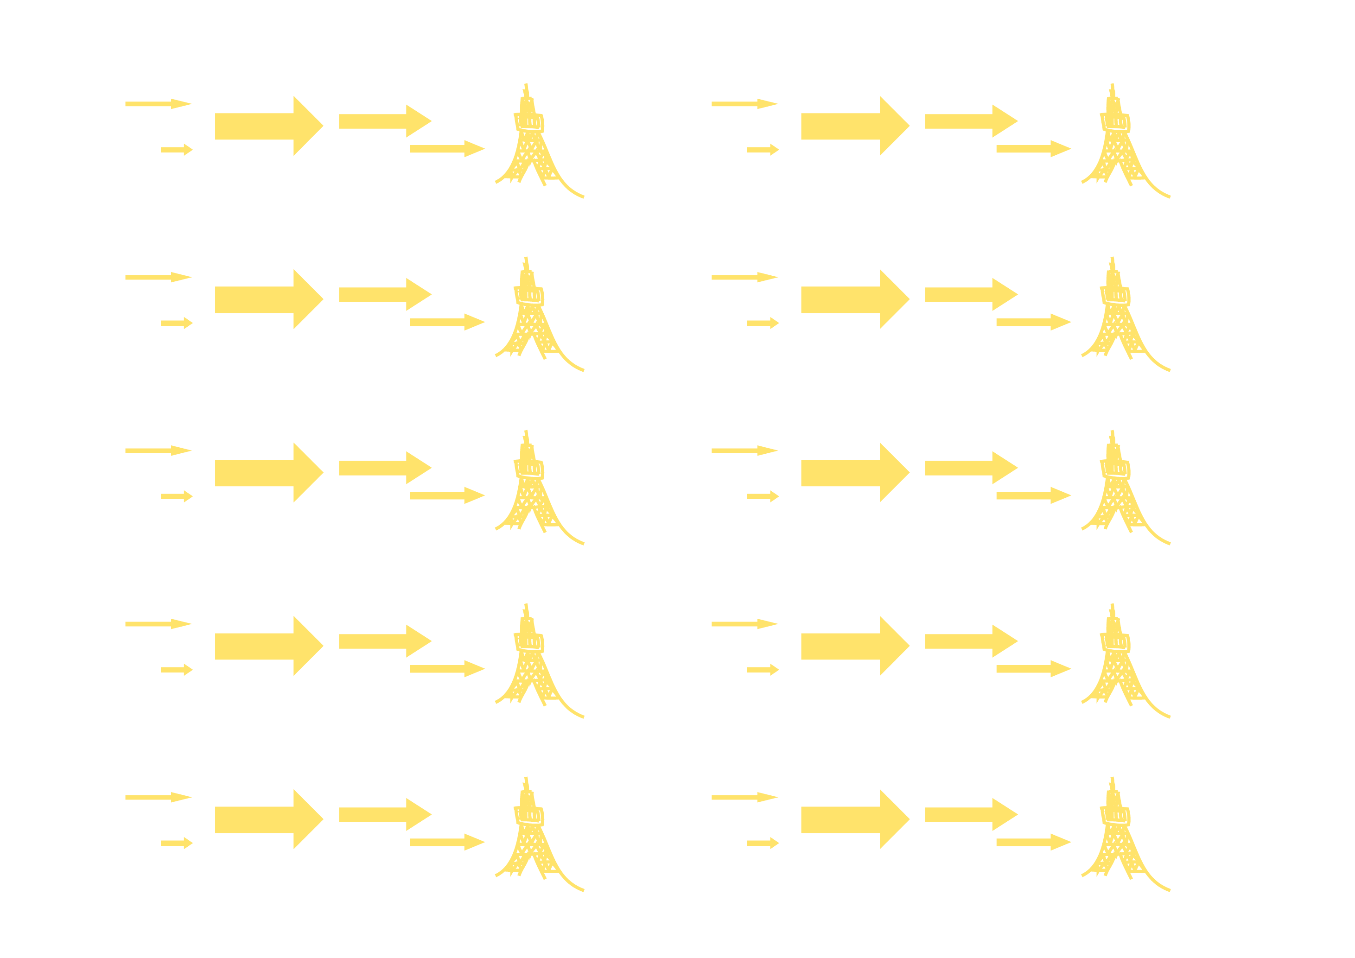
TOKYO NIGHT PARTY
TOKYO NIGHT PARTY
TOKYO NIGHT PARTY
TOKYO NIGHT PARTY
TOKYO NIGHT PARTY
TOKYO NIGHT PARTY
TOKYO NIGHT PARTY
TOKYO NIGHT PARTY
TOKYO NIGHT PARTY
TOKYO NIGHT PARTY

