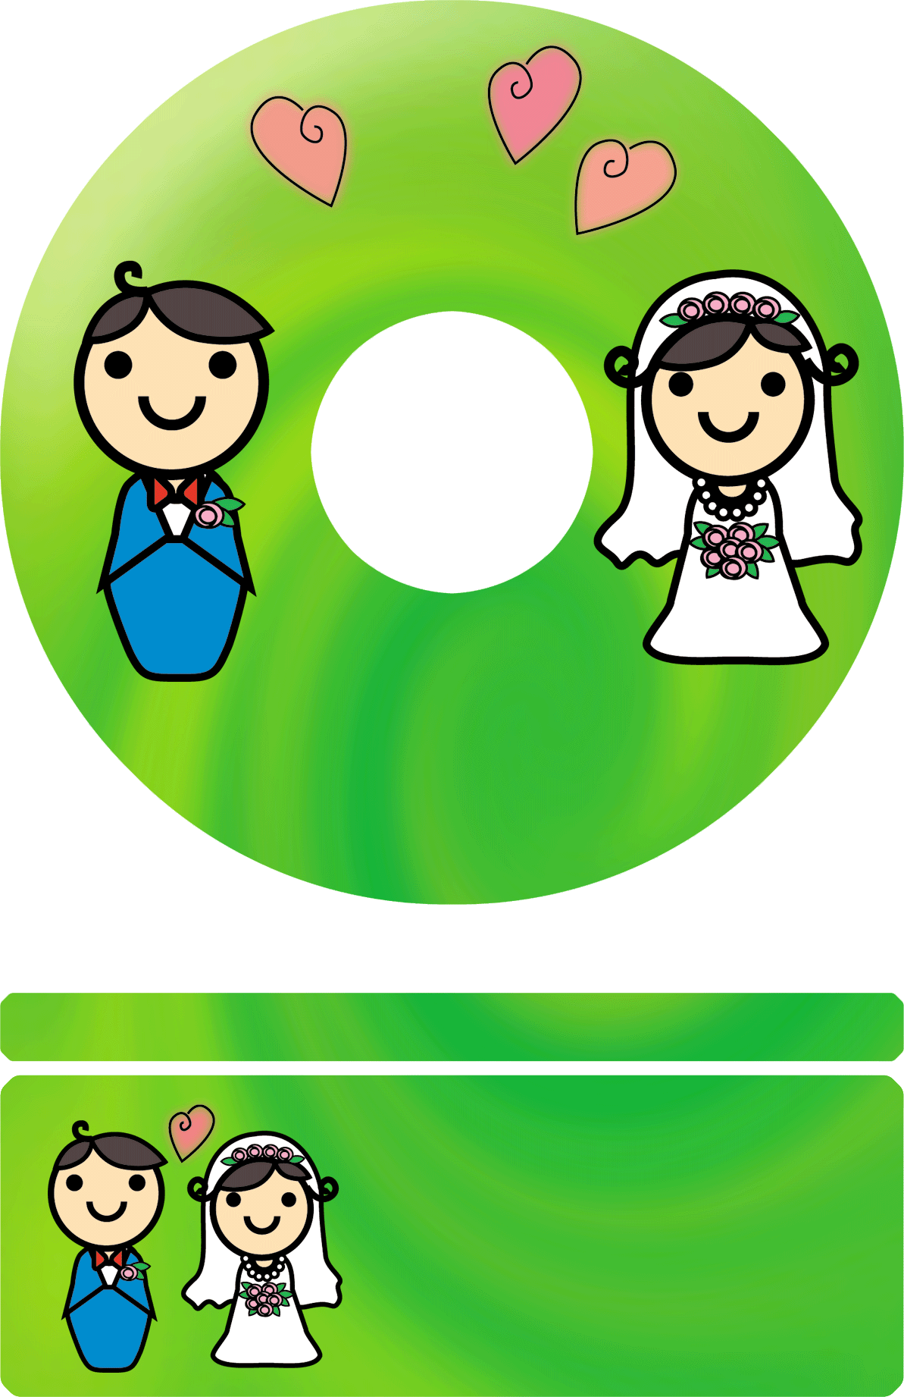



# My Wedding Album

## SATORU & MAKIKO HAPPY WEDDING PARTY

# JUNE

# 6

# 2003

**SATORU & MAKIKO HAPPY WEDDING PARTY**

# My Wedding Album

**SATORU & MAKIKO**

**HAPPY WEDDING PARTY**

# 2003

# JUNE

# 6

# My Wedding Album